**seneca_logo**

**SENECA COLLEGE OF APPLIED ARTS AND TECHNOLOGY**

**SENECA BUSINESS**

[**Academic Integrity Policy**](http://www.senecacollege.ca/about/policies/academic-integrity-policy.html). Seneca upholds a learning community that values academic integrity, honesty, fairness, trust, respect, responsibility and courage. These values enhance Seneca’s commitment to students by delivering high-quality education and teaching excellence, while supporting a positive learning environment. The AI policy is always in effect. Note **Sections** **2.3 and 2.4:**

***“…2.3*** *Should there be a suspected violation of this policy (e.g.…cheating, falsification, impersonation or plagiarism), the academic integrity sanctions will be applied according to the severity of the offence committed. Refer to* [*Appendix B*](http://www.senecacollege.ca/about/policies/academic-integrity-policy.html) *for the academic integrity sanctions.* ***2.4*** *Should a suspected violation of this policy be a result of, or in combination with, a suspected violation of Seneca’s Student Code of Conduct and/or another non-academic-related Seneca policy, the matter will be investigated and adjudicated through the process found in the Student Code of Conduct.”*

|  |
| --- |
| ***TO BE COMPLETED BY STUDENT*** |
| *SUBJECT SECTION NUMBER (e.g. QNM223 AA): BAN210-ZBB* |
| *STUDENT NAME: LESLY PEARL CORTEZ* |
| *STUDENT NUMBER: 108161217* |
| *STUDENT SIGNATURE: LPC* |

**Final Project**

Steps:

1. Download Dataset 1: Breast Cancer Data Set

<https://archive.ics.uci.edu/ml/datasets/Breast+Cancer>

1. Launch SAS Enterprise Miner

1. Create or Open a Project.

1. Create a Diagram.

1. From Sample, drag File import to the Diagram.
   1. Under Train > Import File ***breast-cancer.csv***

* 1. Set the following variable Level to Binary
  2. Right click on the File import node > Edit variable > set Class as “target”

* 1. Select Explore and examine the distribution.

*Exploring Binary variable*

*Exploring Interval variable*

1. From Explore, drag StatExplore to the Diagram.
   1. Run and see Results.

1. From Explore, drag Graph Explore to the Diagram.
   1. Run and see Results.

1. From Explore, drag MultiPlot to the Diagram.
   1. Run and see Results.

1. From Sample, drag Data Partition to the Diagram.
   1. Split the data to training, validation, and test as follows:-

1. From Modify, drag Replacement node to the Diagram
   1. In Class Variables > Replacement Editor > select the Ellipsis.

* 1. Enter \_MISSING\_ as the Replacement Value for observations with the value **?**
  2. Enter \_UKNOWN\_ as the Replacement Value for observation with the value in Date format.

* 1. Select Run and check results.

1. From Modify, drag Impute node to the Diagram.
   1. Select Tree Surrogate as input method for Class and Interval Variables.

* 1. Set up the fields in the Indicator Variables as below.

* 1. Select Run and check results.

1. From Modify, drag Transform node to the Diagram.
   1. Right click on the Transform node > Edit variable > set Max. Normal in the Method column for the variable below.

* 1. Select Run and check results.

* 1. In Exported Data > click ellipsis and the select TRAIN > Explore

* 1. Select Plot > Histogram > Next and the variable **Replacement: deg-malig** > Finish

1. From Utility, drag Start Group node to the Diagram.
   1. In General > Mode > set to Cross-Validation

* 1. Select Run and check results.

1. From Model, drag Decision Tree to the Diagram.
   1. Under Splitting Rule, do not change the default.

* 1. Under Cross Validation > Perform Cross Validation > set to YES

* 1. Run Decision Tree Node
  2. Once run completed successfully, check for the result.

1. From Model, drag Regression node to the Diagram.
   1. Under Class Target, set Regression Type as “Linear Regression”
   2. Under Model Option, set Input Coding as “GLM”
   3. Under Model Selection, set Selection Model as “Stepwise”

* 1. Run Regression Node
  2. Once run completed successfully, check for the result

1. From Utility, drag Control Point in the Diagram
2. From Access, drag Model Comparison in the Diagram

1. From Utility, drag End Group in the Diagram

1. From Assess, drag Score in the Diagram

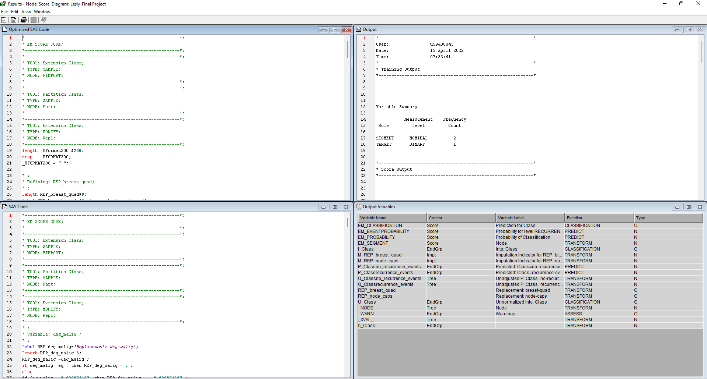

I, Lesly Pearl Cortez, declare that the attached assignment is my own work in accordance with the Seneca Academic Policy. I have not copied any part of this assignment, manually or electronically, from any other source including web sites, unless specified as references. I have not distributed my work to other students.